DBMS Lab

Assignment - 5

Dated: 22-02-2021

Sub Code: CSE-227

**Vivek Kumar Ahirwar**

**191112419**

**CSE - 3**

Department of

Computer Science and Engineering

Subject Coordinator:

Dr. Sweta Jain, & Dr. Nikhil Kumar Singh



**Maulana Azad**

**National Institute of Technology,**

**BHOPAL – 462 003 (INDIA)**

**DBMS: LAB-ASSIGNMENT-5 22-02-2021**

1. Retrieve the birth date and address of the employee(s) whose name is ‘John B. Smith’.

select Bdate, Address

from employee

where  (Fname,Minit,Lname) = ('John','B','Smith');

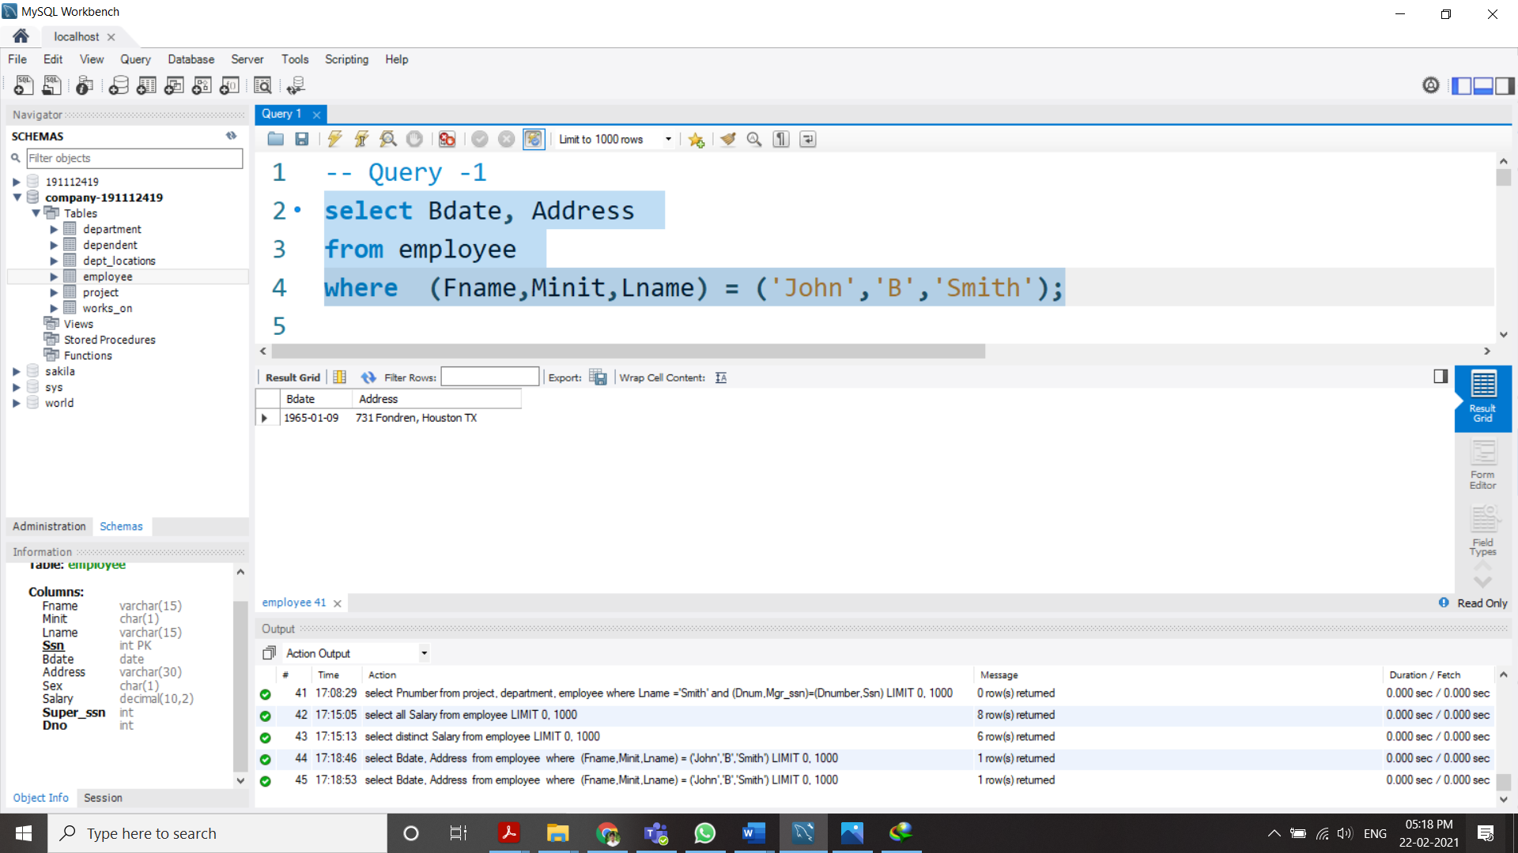

1. Retrieve the name and address of all employees who work for the ‘Research’ department.

select **CONCAT**(Fname,' ', Minit, '. ', Lname) as Name, Address

from employee, department

where Dname='Research';

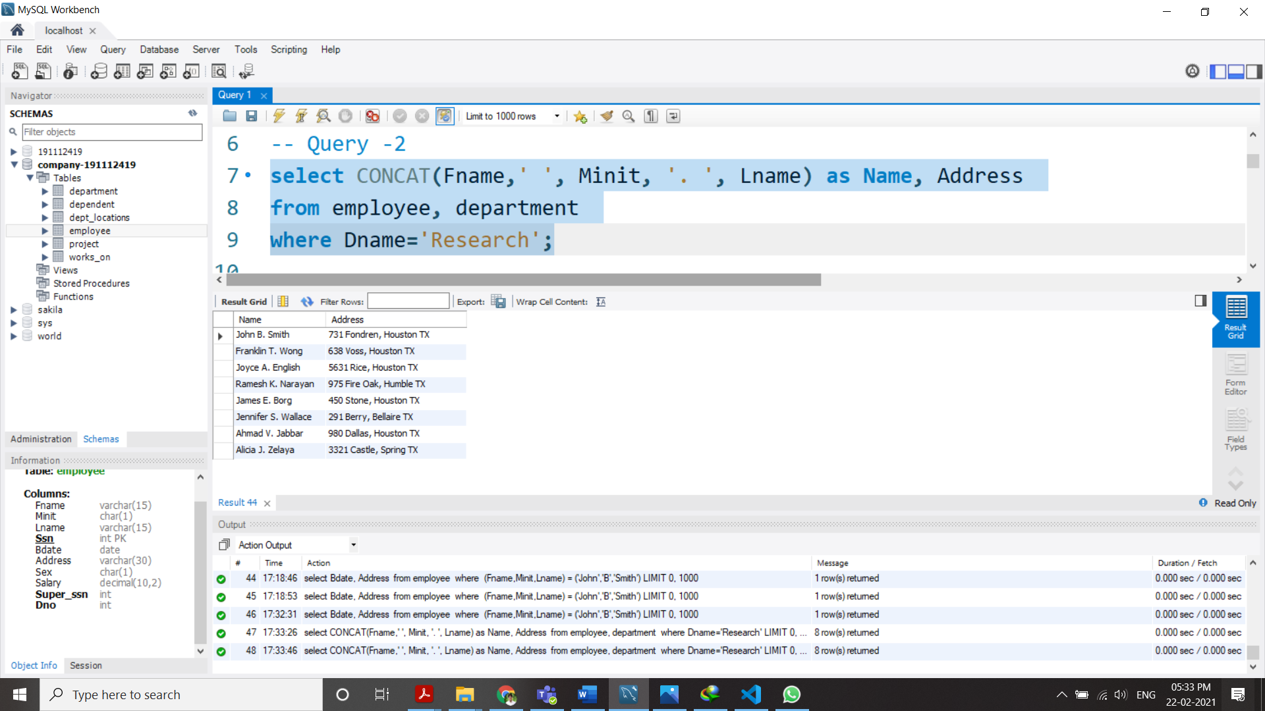

1. For every project located in ‘Stafford’, list the project number, the controlling department number, and the department manager’s last name, address, and birth date.

select Pnumber, Dnum, Lname, Address, Bdate

from  project, department, employee

where Plocation='Stafford' and Dnumber=Dnum and Ssn = Mgr_ssn ;

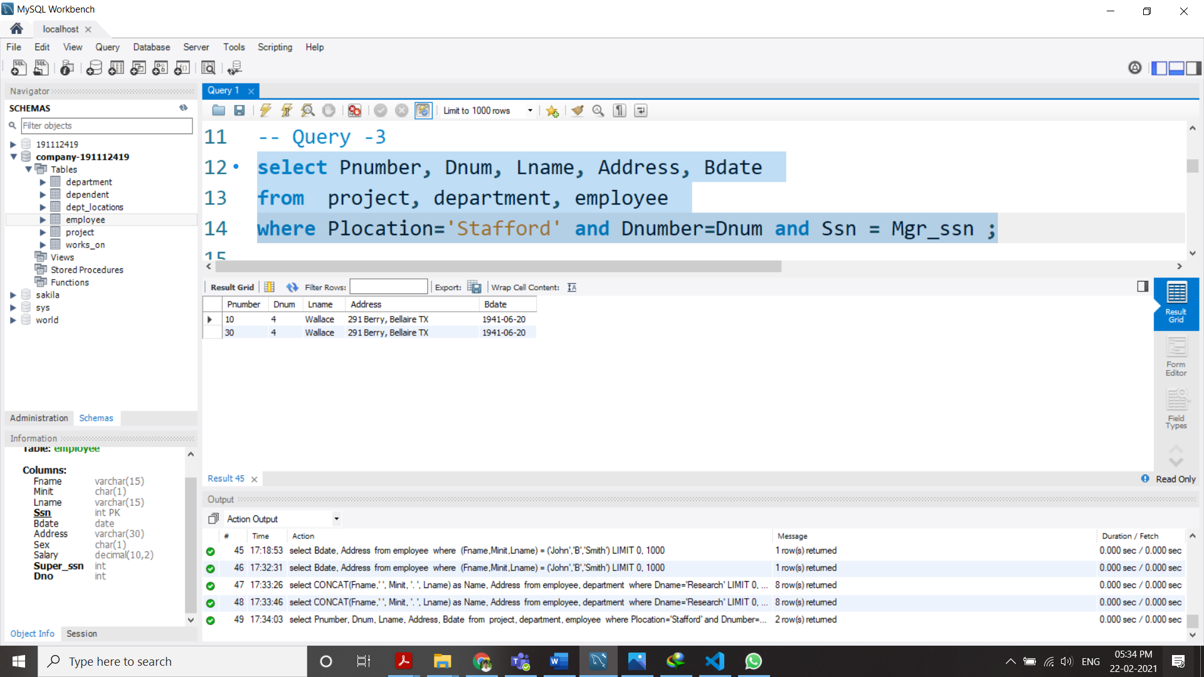

1. For each employee, retrieve the employee’s first and last name and the first and last name of his or her immediate supervisor.

select E.Fname, E.Lname, S.Fname, S.Lname

from employee as E, employee as S

where S.Ssn = E.Super_ssn;

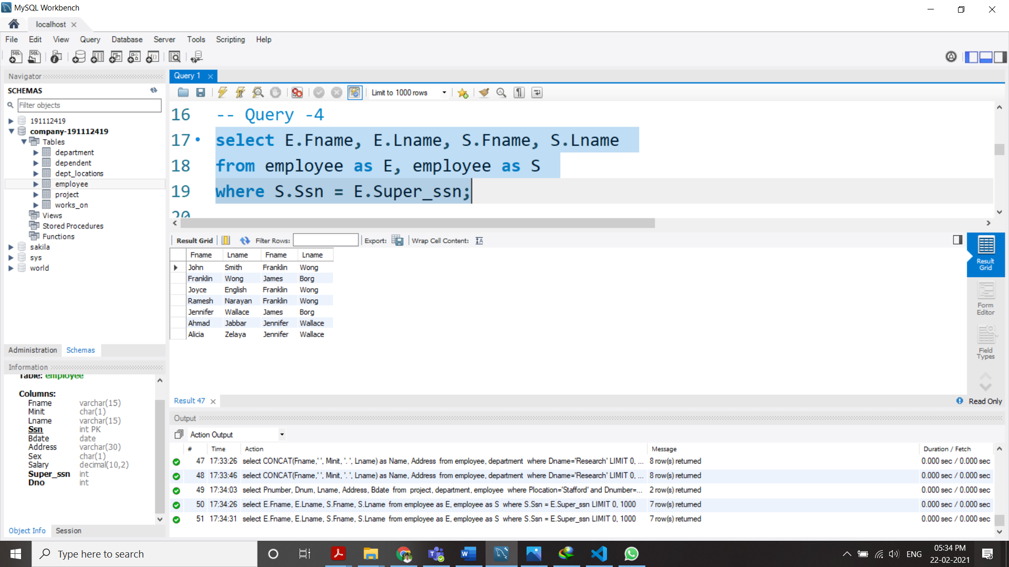

1. Retrieve the salary of every employee and all distinct salary values

select all Salary from employee;

select distinct Salary from employee;

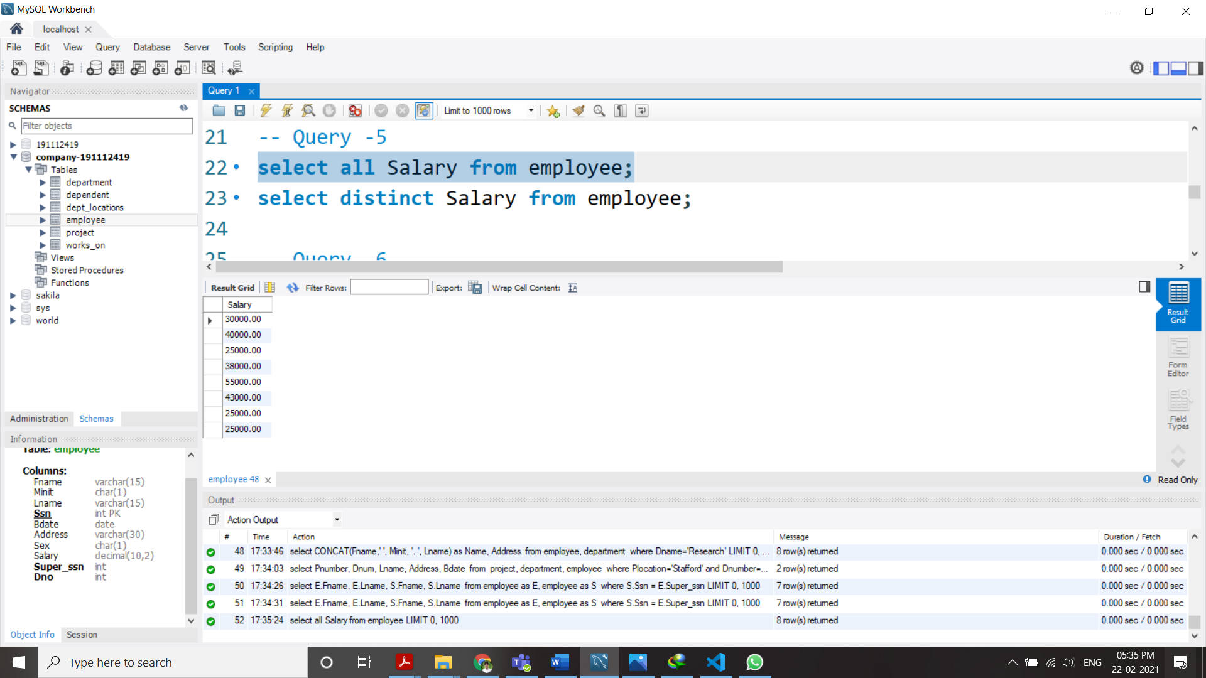

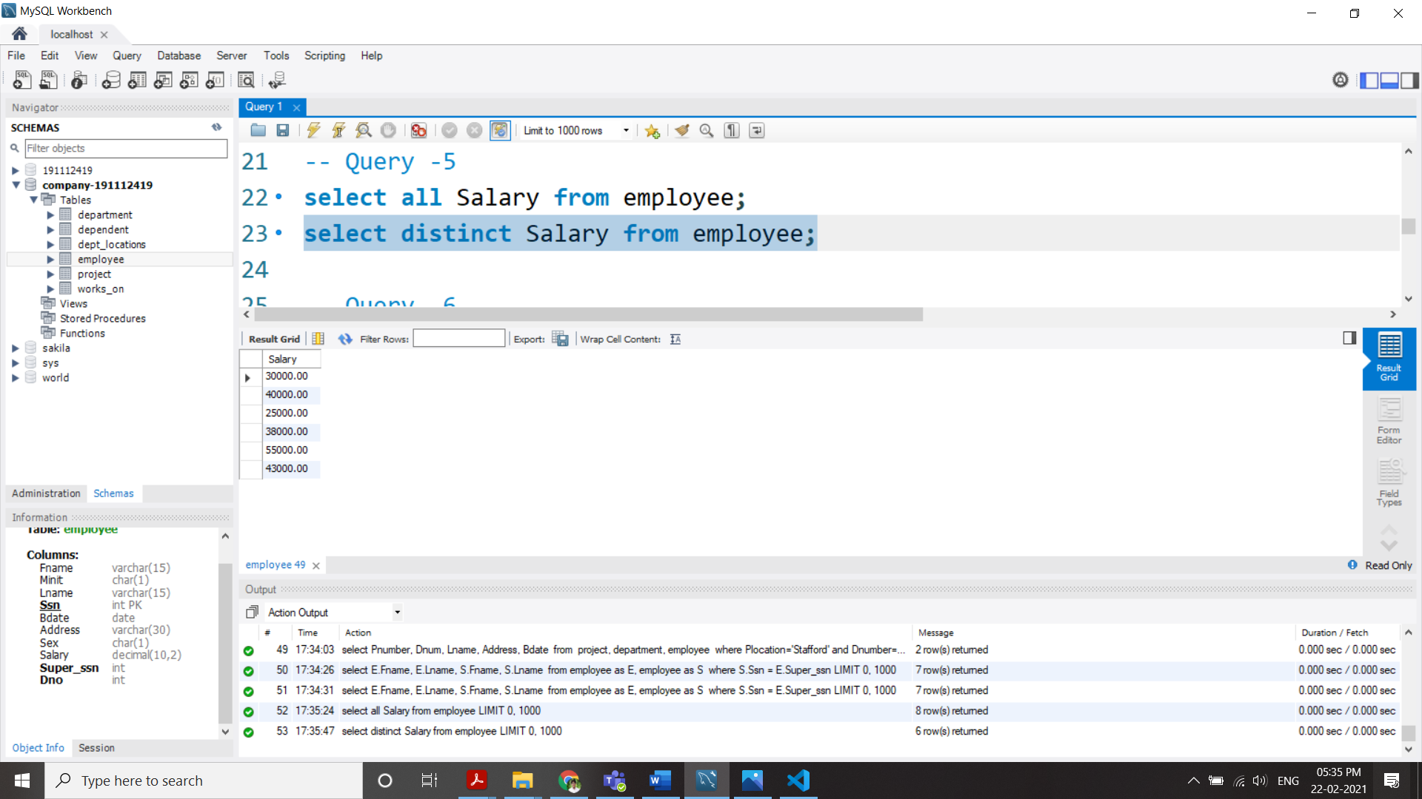

1. Make a list of all project numbers for projects that involve an employee whose last name is ‘Smith’, either as a worker or as a manager of the department that controls the project.

(select Pnumber from project, works_on, employee

where Lname ='Smith' and (Pnumber,Essn)=(Pno,Ssn) )

union

(select Pnumber from project, department, employee

where Lname ='Smith' and (Dnum,Mgr_ssn)=(Dnumber,Ssn) );

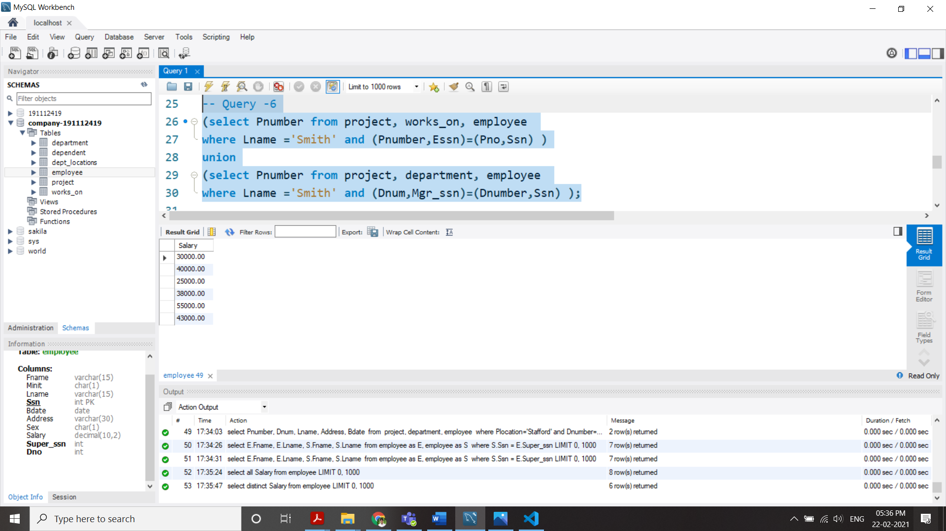

1. Retrieve all employees whose address is in Houston, Texas.

select * from employee where Address like '%Houston TX%';

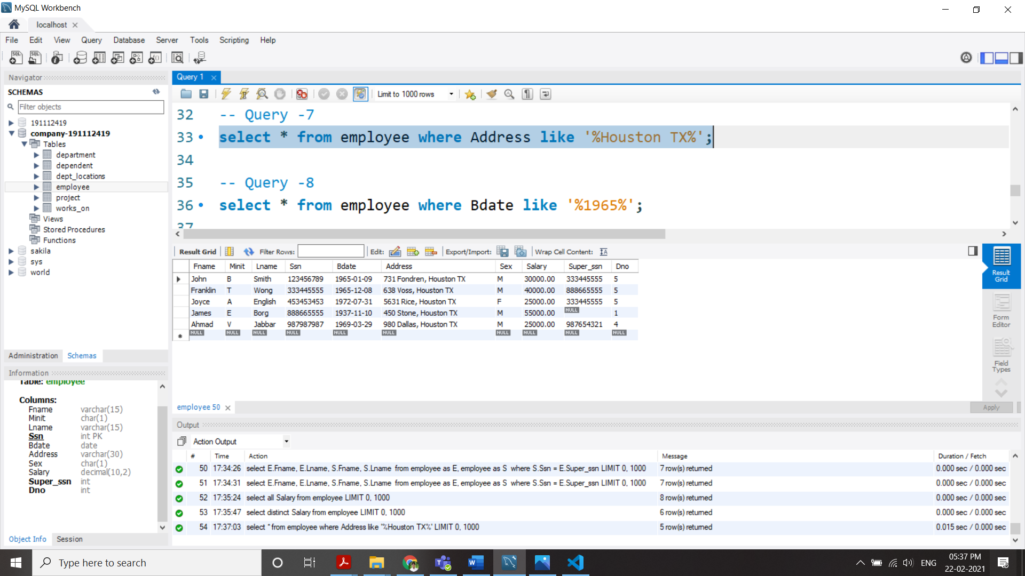

1. Find all employees who were born in 1958s.

select * from employee where Bdate like '%1965%';

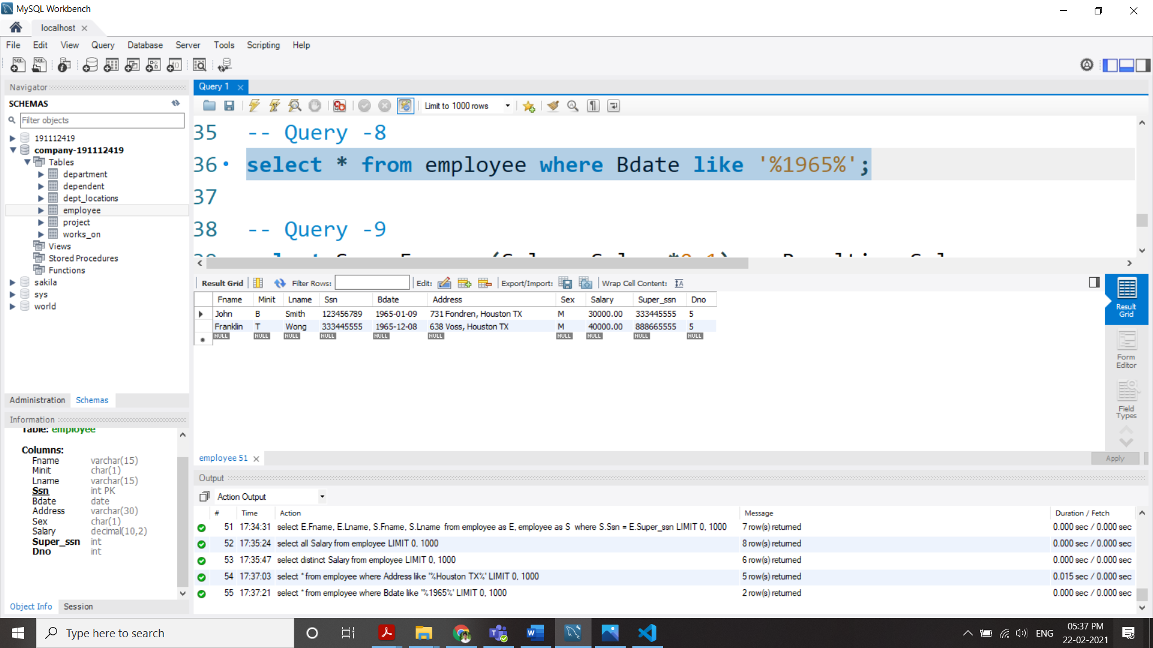

1. Show the resulting salaries if every employee working on the ‘ProductX’ project is given a 10% raise.

select Ssn, Fname, (Salary+Salary*0.1) as Resulting_Salary

from employee, works_on, project

where Pname='ProductX' and employee.Ssn = works_on.Essn and works_on.Pno = project.Pnumber;

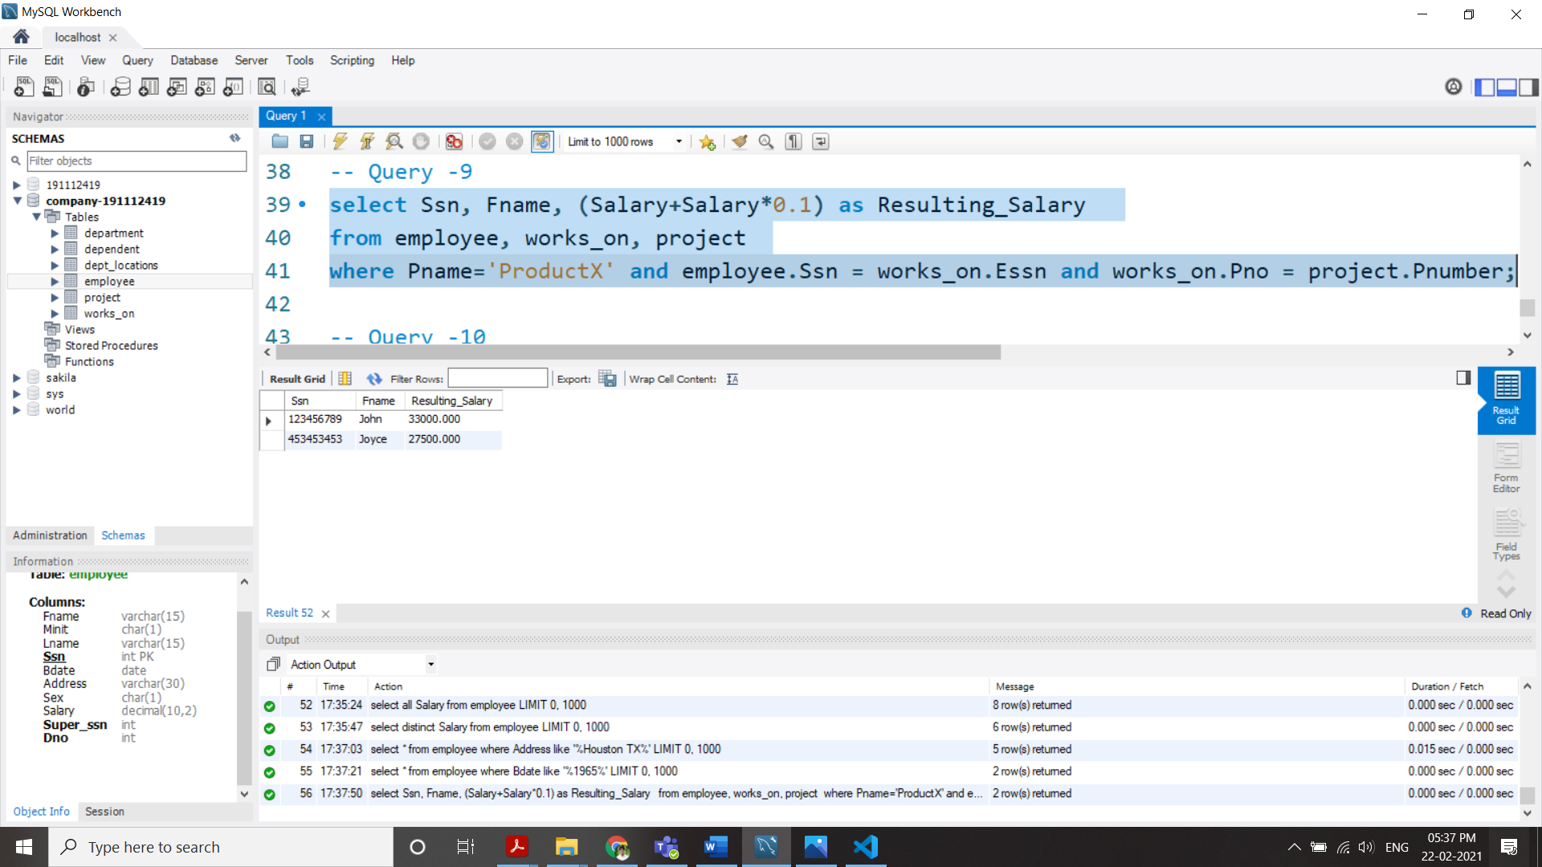

1. Retrieve all employees in department 5 whose salary is between $30,000 and $40,000.

select * from employee

where Dno = 5 and Salary between 30000 and 40000;

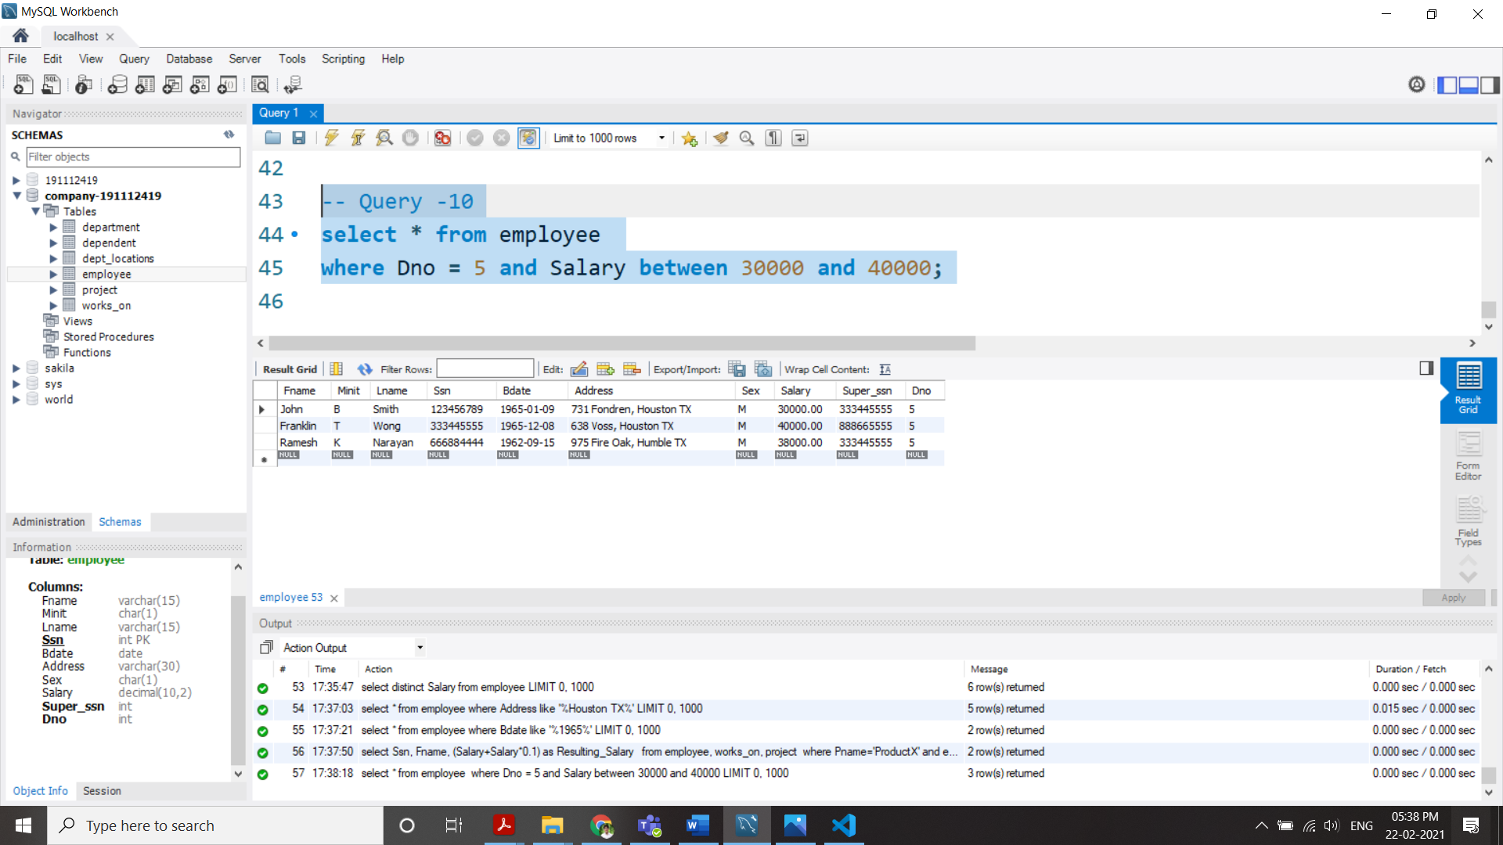

All SQL Queries:

*-- Query -1*

select Bdate, Address

from employee

where  (Fname,Minit,Lname) = ('John','B','Smith');

*-- Query -2*

select **CONCAT**(Fname,' ', Minit, '. ', Lname) as Name, Address

from employee, department

where Dname='Research';

*-- Query -3*

select Pnumber, Dnum, Lname, Address, Bdate

from  project, department, employee

where Plocation='Stafford' and Dnumber=Dnum and Ssn = Mgr_ssn ;

*-- Query -4*

select E.Fname, E.Lname, S.Fname, S.Lname

from employee as E, employee as S

where S.Ssn = E.Super_ssn;

*-- Query -5*

select all Salary from employee;

select distinct Salary from employee;

*-- Query -6*

(select Pnumber from project, works_on, employee

where Lname ='Smith' and (Pnumber,Essn)=(Pno,Ssn) )

union

(select Pnumber from project, department, employee

where Lname ='Smith' and (Dnum,Mgr_ssn)=(Dnumber,Ssn) );

*-- Query -7*

select * from employee where Address like '%Houston TX%';

*-- Query -8*

select * from employee where Bdate like '%1965%';

*-- Query -9*

select Ssn, Fname, (Salary+Salary*0.1) as Resulting_Salary

from employee, works_on, project

where Pname='ProductX' and employee.Ssn = works_on.Essn and works_on.Pno = project.Pnumber;

*-- Query -10*

select * from employee

where Dno = 5 and Salary between 30000 and 40000;